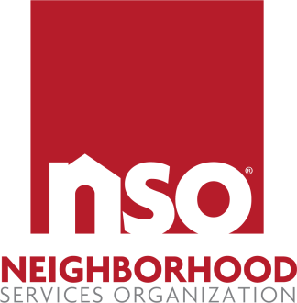

JOB DESCRIPTION

JOB TITLE: CWC Front Desk Monitor | FLSA STATUS: Non-Exempt
REPORTS TO: Housing Director | WORKS SCHEDULE: Full Time
PROGRAM/DEPARTMENT: Housing | APPROVED BY: CEO

SUMMARY: The Front Desk Monitor will understand and model the mission of NSO. The Front Desk Monitor will understand and practice NSO’s policy on confidentiality in respect to all NSO information. The Front Desk Monitor will exhibit professional behavior in all facets of work at NSO.

The Front Desk Monitor maintains a continuous state of alertness and awareness to control and secure NSO properties as needed. The Overnight Monitor ensures all clients abide by all rules and regulations. In addition, the Overnight Monitor is to ensure the client kitchen is maintained in an organized manner, to make meal preparations for breakfast and to assist clients with chores for cleaning the facility.

ESSENTIAL FUNCTIONS:
- Physically patrol the internal areas of the facility to visually observe and listen to clients and monitor the state of the facilities. Ensure doors and windows are properly secure.
- Make initial contact with any visitors and verify their identity.
- Maintain legible, accurate and concise records in night monitor log so staff on all shifts are continuously informed of the status of clients and facilities.
- Must be a liaison between residents and Client Advocates. Report on the log when clients violate rules.
- Communicate with client and staff in a professional manner to affirm and enhance self-esteem and dignity, and to maintain positive client/staff relations.
- Be familiar with the goals of the program so clients’ needs are met.
- Conduct scheduled and impromptu cleanliness checks of facilities to maintain it in an orderly and clean fashion to meet health and environmental requirements. Must help keep CWC premises safe, clean, and tour ready at all times.
- Perform random nightly room checks to ensure all residents are complying with NSO program rules.
- Perform random building checks on weekends to ensure security and program compliance by all clients.
- Effectively work and cooperate with supervisors, co-workers, and clients.
- Other duties may be assigned by supervisors.

JOB REQUIREMENTS:
Minimum Requirement: High School diploma or equivalent required. One year of general work experience. Clearance and pass of background check and drug screen.

SKILLS AND ABILITIES REQUIRED:
- Requires clear, oral, and written communication skills.
- Requires basic knowledge of computer literacy skills.
- Requires patience when assisting population served.
- Requires ability to handle multiple projects and tasks simultaneously.
- Requires clear oral and written communication skills.
- Requires the ability to work independently as well as part of a team.
- Requires knowledge of safety policies and procedures. Adherence to policies and procedures are a must.

SCHEDULE:
Sunday - Wednesday 7:00 pm to 5:00 am

WORKING CONDITIONS:
- This job requires moderate physical activity performing somewhat strenuous daily activities.
- The majority of time spent in this position is in a comfortable, climate-controlled setting.

The qualifications, physical demands, and work environment described herein are representative of those an employee will encounter and must meet to successfully perform the essential functions of this job. Reasonable accommodations may be made to enable individuals with disabilities to perform the essential functions. The requirements listed in this document are the minimum levels of knowledge, skills, and abilities.

